# **Name: Abdurrahman Qureshi**

# **Roll No: 242466**

Practical No: 6

1) **Order employees by ascending**

QUERY:

SELECT * FROM emp ORDER BY salary ASC;

OUTPUT:

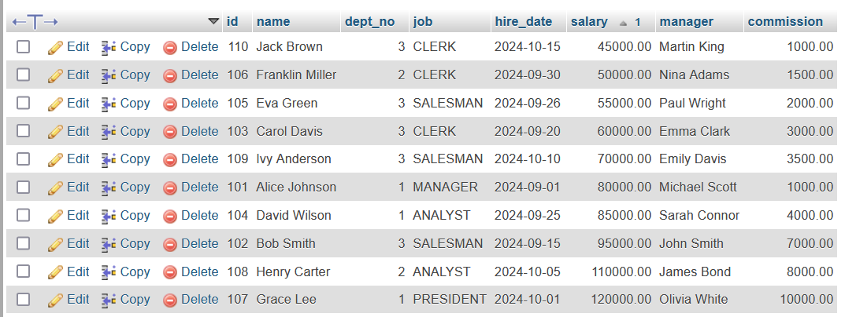

2) **Order employees by descending**

QUERY:

SELECT * FROM emp ORDER BY salary DESC;

OUTPUT:

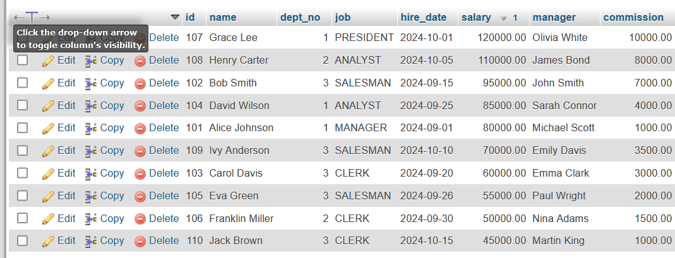

3) Group employees by department and calculate the total salary per department

QUERY:

SELECT dept_no, SUM(salary) AS total_salary

FROM emp

GROUP BY dept_no;

OUTPUT:

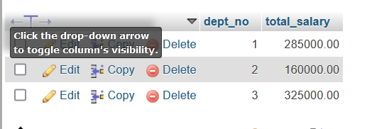

4) Get **min, max , avg salaray per department**

QUERY:

SELECT MIN(salary), MAX(salary), AVG(salary) FROM emp GROUP BY dept_no;

OUTPUT:

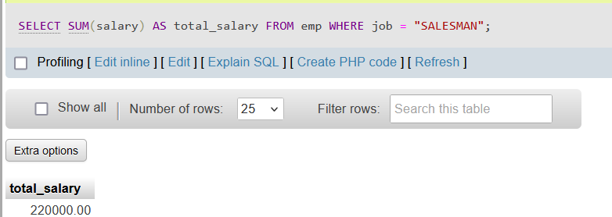

5) **Get min salary from all jobs**

QUERY:

SELECT job, MIN(salary) AS min_salary

FROM emp

GROUP BY job;

OUTPUT:

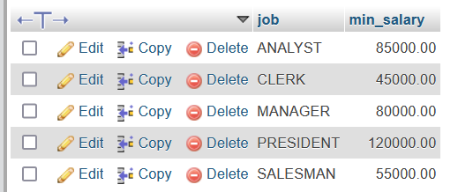

6) **Get salary greater than 80000**

QUERY:

SELECT *

FROM emp

HAVING salary > 80000;

OUTPUT:

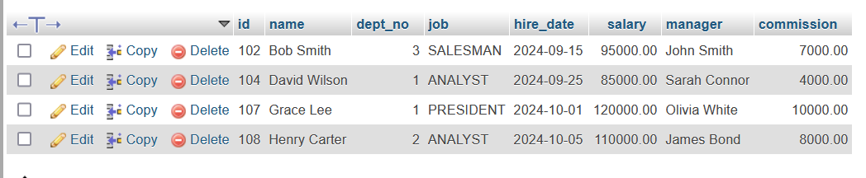

7) **Order by ename**

QUERY:

SELECT dept_no FROM `emp` ORDER BY name;

OUTPUT:

